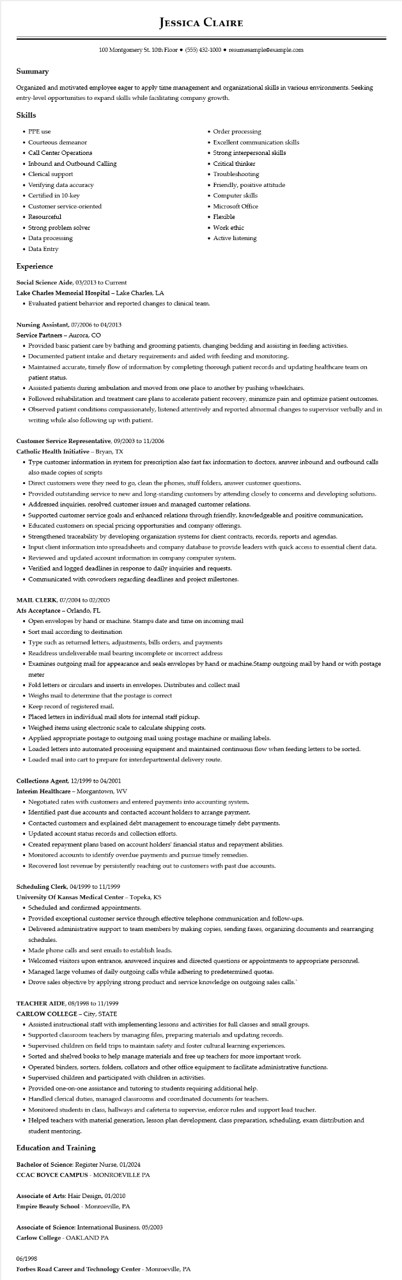
JESSICA CLAIRE
100 Montgomery St. 10th Floor⚫ (555) 432-1000⚫ resumesample@example.com
Summary
Organized and motivated employee eager to apply time management and organizational skills in various environments. Seeking entry-level opportunities to expand skills while facilitating company growth.
Skills
• PPE use
• Courteous demeanor
• Call Center Operations
• Inbound and Outbound Calling
• Clerical support
• Verifying data accuracy
• Certified in 10-key
• Customer service-oriented
• Resourceful
• Strong problem solver
• Data processing
• Data Entry
Experience
Social Science Aide, 03/2013 to Current
Lake Charles Memorial Hospital - Lake Charles, LA
• Order processing
• Excellent communication skills
• Strong interpersonal skills
• Critical thinker
• Troubleshooting
• Friendly, positive attitude
•
• Evaluated patient behavior and reported changes to clinical team.
Nursing Assistant, 07/2006 to 04/2013
Service Partners - Aurora, CO
Computer skills
• Microsoft Office
• Flexible
• Work ethic
• Active listening
• Provided basic patient care by bathing and grooming patients, changing bedding and assisting in feeding activities.
• Documented patient intake and dietary requirements and aided with feeding and monitoring.
• Maintained accurate, timely flow of information by completing thorough patient records and updating healthcare team on patient status.
• Assisted patients during ambulation and moved from one place to another by pushing wheelchairs.
• Followed rehabilitation and treatment care plans to accelerate patient recovery, minimize pain and optimize patient outcomes.
• Observed patient conditions compassionately, listened attentively and reported abnormal changes to supervisor verbally and in writing while also following up with patient.
Customer Service Representative, 09/2003 to 11/2006
Catholic Health Initiative - Bryan, TX
• Type customer information in system for prescription also fast fax information to doctors, answer inbound and outbound calls also made copies of scripts
• Direct customers were they need to go, clean the phones, stuff folders, answer customer questions.
• Provided outstanding service to new and long-standing customers by attending closely to concerns and developing solutions.
• Addressed inquiries, resolved customer issues and managed customer relations.
•
Supported customer service goals and enhanced relations through friendly, knowledgeable and positive communication.
• Educated customers on special pricing opportunities and company offerings.
• Strengthened traceability by developing organization systems for client contracts, records, reports and agendas.
• Input client information into spreadsheets and company database to provide leaders with quick access to essential client data.
• Reviewed and updated account information in company computer system.
• Verified and logged deadlines in response to daily inquiries and requests.
• Communicated with coworkers regarding deadlines and project milestones.
MAIL CLERK, 07/2004 to 02/2005
Afs Acceptance - Orlando, FL
•
Open envelopes by hand or machine. Stamps date and time on incoming mail
• Sort mail according to destination
• Type such as returned letters, adjustments, bills orders, and payments
• Readdress undeliverable mail bearing incomplete or incorrect address
• Examines outgoing mail for appearance and seals envelopes by hand or machine.Stamp outgoing mail by hand or with postage
meter
• Fold letters or circulars and inserts in envelopes. Distributes and collect mail
• Weighs mail to determine that the postage is correct
• Keep record of registered mail.
• Placed letters in individual mail slots for internal staff pickup.
• Weighed items using electronic scale to calculate shipping costs.
• Applied appropriate postage to outgoing mail using postage machine or mailing labels.
• Loaded letters into automated processing equipment and maintained continuous flow when feeding letters to be sorted.
• Loaded mail into cart to prepare for interdepartmental delivery route.
Collections Agent, 12/1999 to 04/2001
Interim Healthcare - Morgantown, WV
• Negotiated rates with customers and entered payments into accounting system.
• Identified past due accounts and contacted account holders to arrange payment.
• Contacted customers and explained debt management to encourage timely debt payments. • Updated account status records and collection efforts.
• Created repayment plans based on account holders' financial status and repayment abilities.
• Monitored accounts to identify overdue payments and pursue timely remedies.
• Recovered lost revenue by persistently reaching out to customers with past due accounts.
Scheduling Clerk, 04/1999 to 11/1999
University of Kansas Medical Center - Topeka, KS
• Scheduled and confirmed appointments.
• Provided exceptional customer service through effective telephone communication and follow-ups.
• Delivered administrative support to team members by making copies, sending faxes, organizing documents and rearranging schedules.
• Made phone calls and sent emails to establish leads.
• Welcomed visitors upon entrance, answered inquires and directed questions or appointments to appropriate personnel.
• Managed large volumes of daily outgoing calls while adhering to predetermined quotas.
• Drove sales objective by applying strong product and service knowledge on outgoing sales calls.`
TEACHER AIDE, 08/1998 to 11/1999
CARLOW COLLEGE - City, STATE
• Assisted instructional staff with implementing lessons and activities for full classes and small groups.
• Supported classroom teachers by managing files, preparing materials and updating records.
• Supervised children on field trips to maintain safety and foster cultural learning experiences.
• Sorted and shelved books to help manage materials and free up teachers for more important work.
•
·
Operated binders, sorters, folders, collators and other office equipment to facilitate administrative functions.
Supervised children and participated with children in activities.
• Provided one-on-one assistance and tutoring to students requiring additional help.
• Handled clerical duties, managed classrooms and coordinated documents for teachers.
• Monitored students in class, hallways and cafeteria to supervise, enforce rules and support lead teacher.
• Helped teachers with material generation, lesson plan development, class preparation, scheduling, exam distribution and
student mentoring.
Education and Training
Bachelor of Science: Register Nurse, 01/2024
CCAC BOYCE CAMPUS - MONROEVILLE PA
Associate of Arts: Hair Design, 01/2010
Empire Beauty School - Monroeville, PA
Associate of Science: International Business, 05/2003
Carlow College - OAKLAND PA
06/1998
Forbes Road Career and Technology Center - Monroeville, PA

